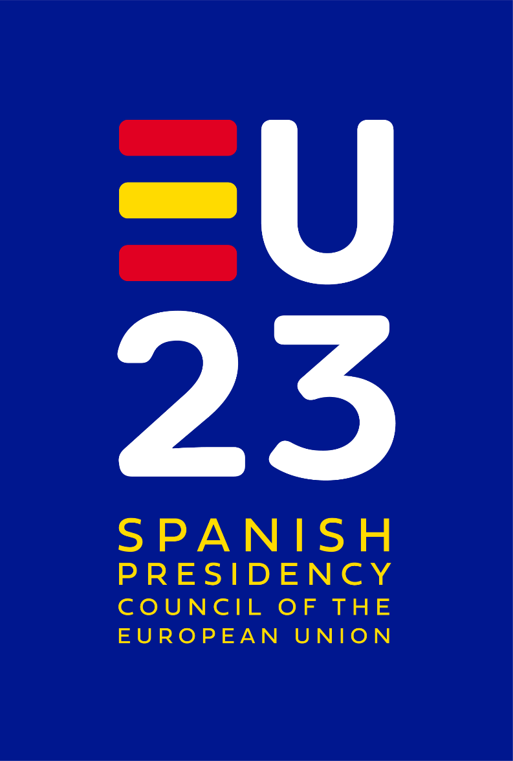
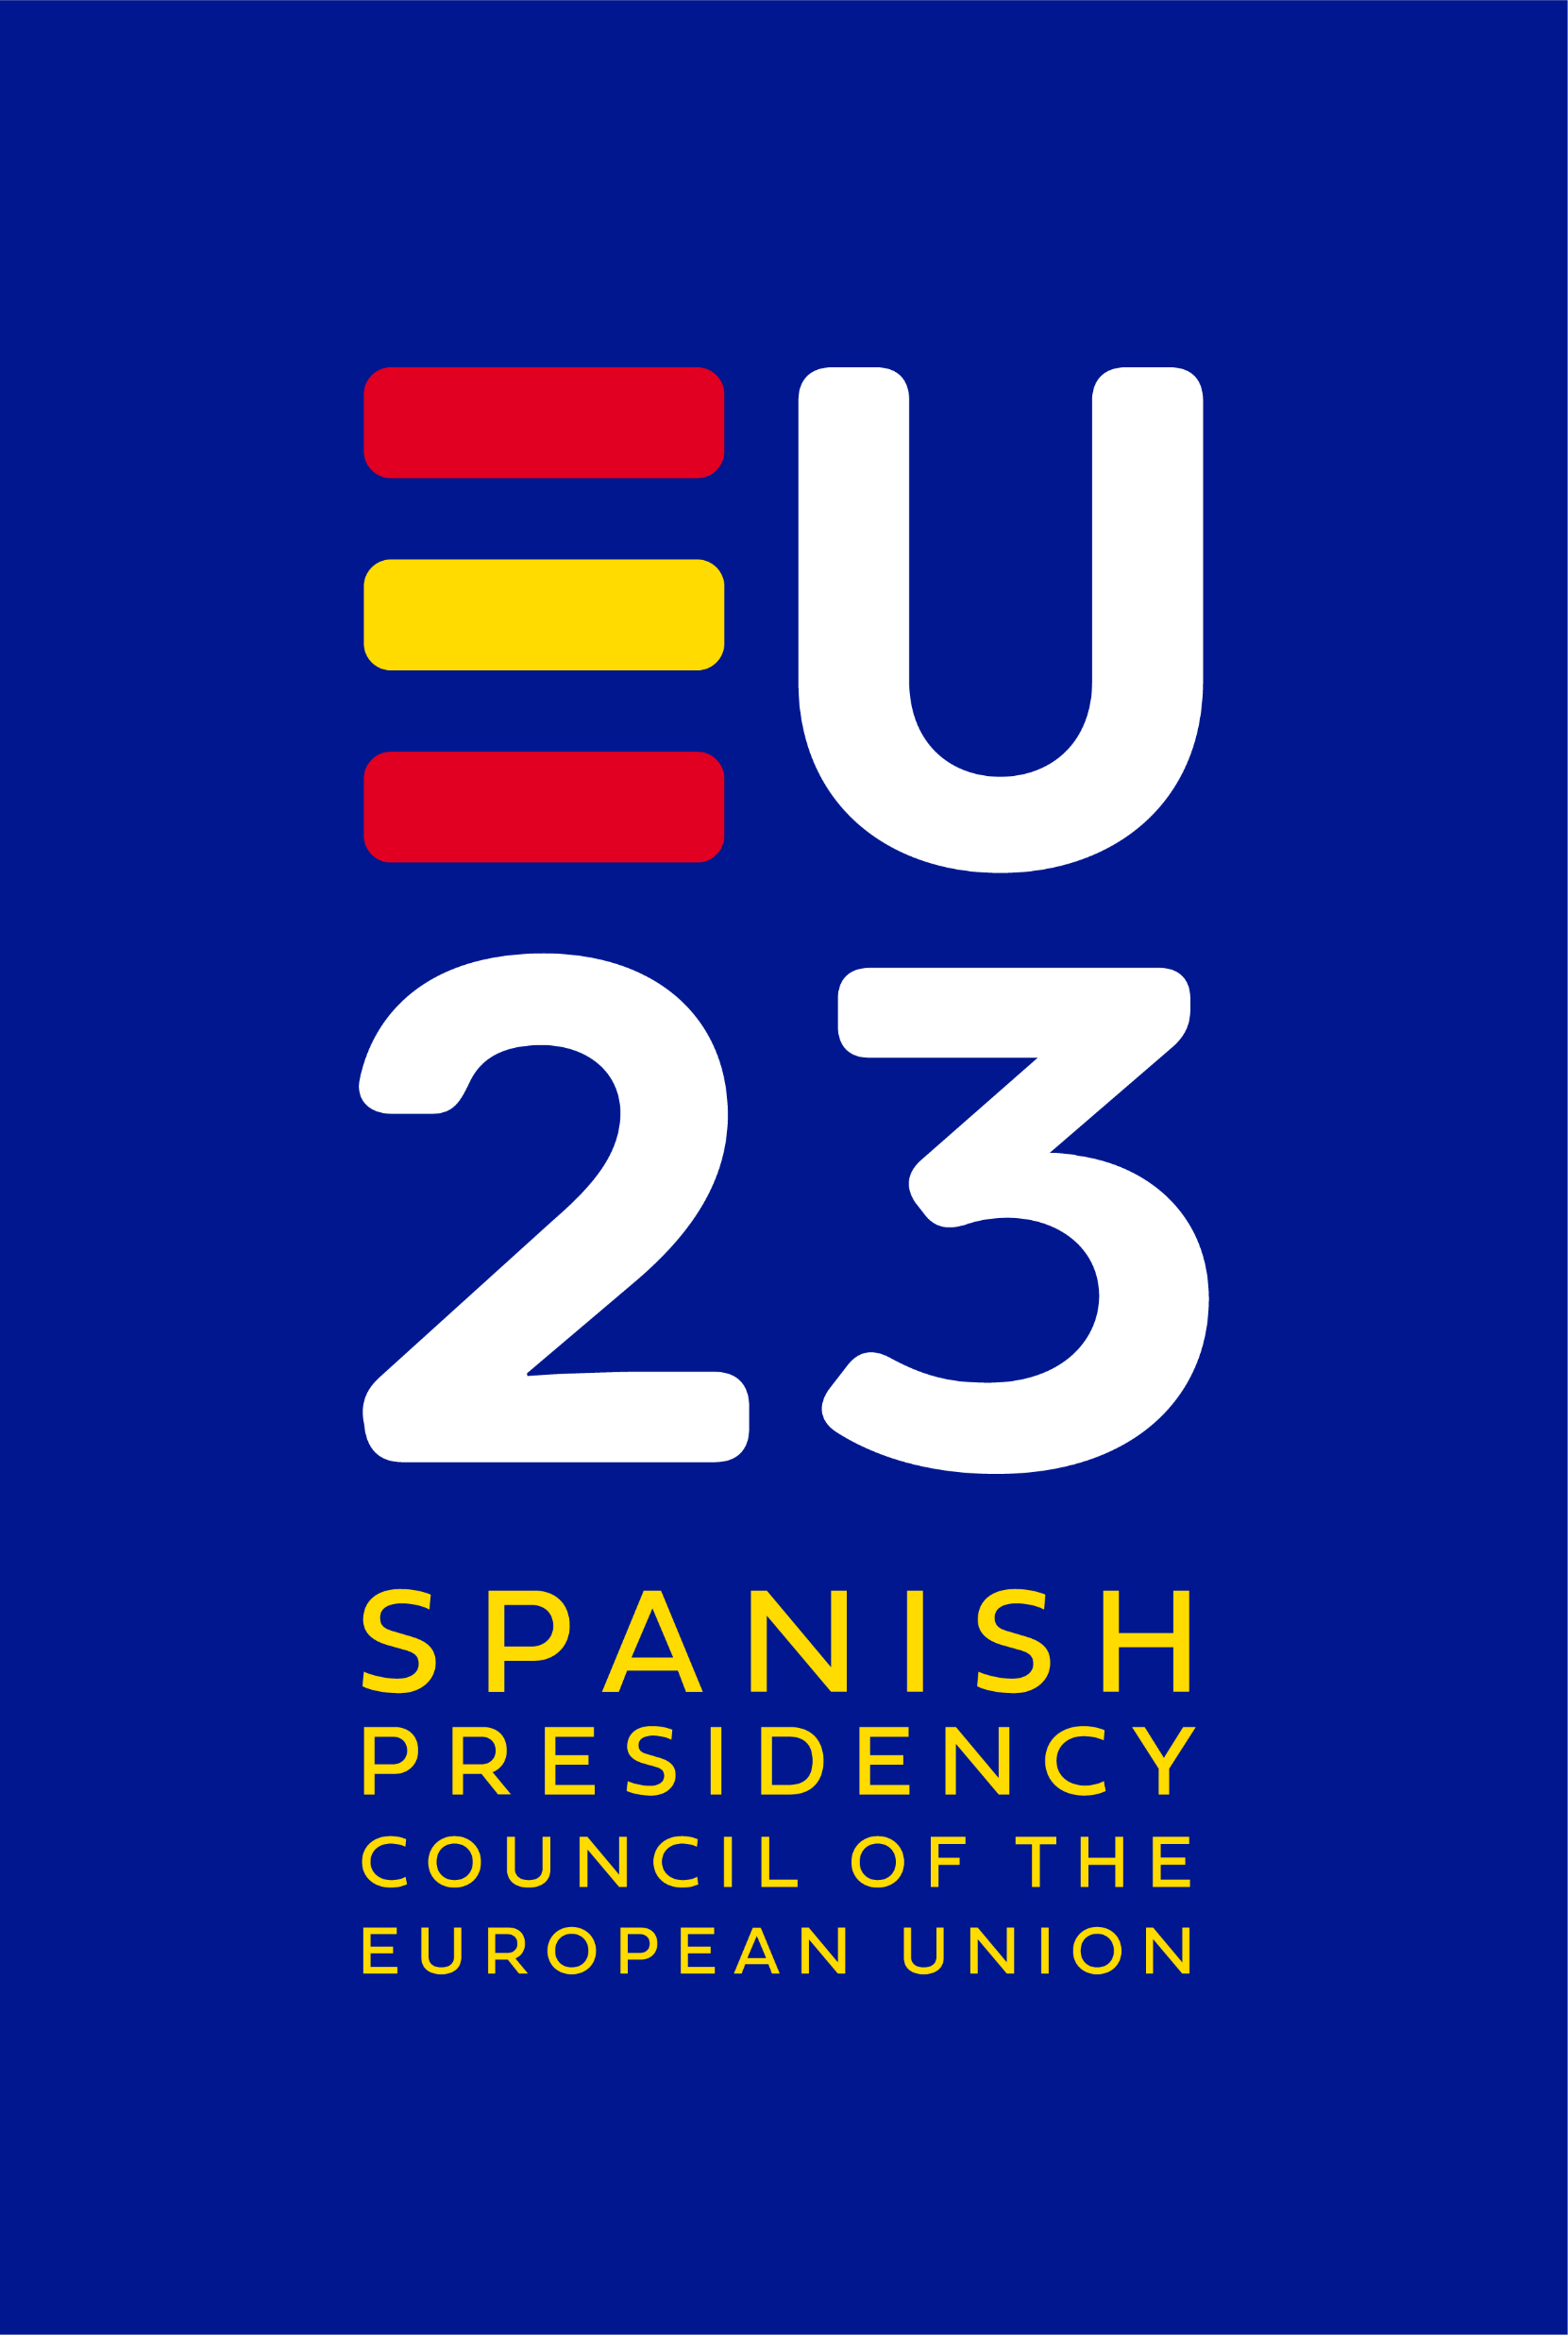
Practical Information Note
- Informal Meeting of Directors-General for Sport
- Conference on Safe Environment
- Opening of the European Week of Sport

21-23 September 2023
Valencia, Spain

Index
General information 4
Venues and dates 4
Delegation size 5
Badges and accreditation 6
Transfers and public transport 6
Security 8
Accommodation 9
Meeting venue and facilities 9
Catering 9
Interpretation 9
Contact 9
General information 10
Presidency website 10

General information
The Spanish Presidency of the Council of the European Union is delighted to have the opportunity to welcome you to Valencia for several consecutive events. The Valencia Central Presidency Events will start with the Informal meeting of the Directors-General for Sport on 21 pm and 22am September which will be followed by the Conference on Safe Environment for Sports on 22 pm September.
To close these events, we invite you to the official Opening of the European Week of Sport on 23 September that will be followed by the Beactive event that will last the whole day and will finish with the #BEACTIVE NIGHT of Valencia.
For your visit, the Spanish Presidency of the Council of the European Union has the pleasure to convey the following practical information.
Please note that all information may be subject to change, in which case it will be communicated by the Presidency in due time.
This Practical Information Note (PIN) provides general information on logistical and organisational aspects to help you prepare for the meeting and a timeline of steps we kindly ask you to take in advance.
Prior to the event, you will further receive:
• Programme of the events
• Background papers

Venues and dates
DATE | DETAILS | WHERE: VALENCIA
Until 14 September | Closure of the online accreditation platform | Via the online accreditation platform
21 September | Arrival of participants | Palau de les Arts (Ciudad de las artes y las Ciencias (CAC))
21pm and 22am September | Informal Meeting of the Directors-General for Sport | Palau de les Arts. Sala de Toros (CAC)
22pm September | Conference of the Presidency | Palau de les Arts. Sala Magistral (CAC)
23 September | Opening of the European Week of Sport and Beactive Night | Caixa Forum (Ciudad de las artes y las Ciencias)

21 September
14:00 – 15:00 | Registrations and welcome coffee | Palau de les Arts (CAC – Sala de Toros)
15:00 – 18:15 | DG Meeting 1 | Palau de les Arts (CAC - Sala de toros)
18:30-19:00 | Walk to the Oceanogràfic | CAC
19:00- 19:15 | Family Photo | Oceanogràfic
19:15-20:30 | Visit the Oceanogràfic | Oceanogràfic
20:30- 23:30 | Dinner (smart casual) | Sala Oval of the Oceanogràfic
23:30 | Transfer to hotels

22 September
07:00 – 08:00 | Physical Activity | Close to the Ciudad de las artes y las Ciencias
09:00 – 09:30 | Welcome coffee | Palau de les Arts. Sala de Toros (CAC)
09:30 – 13:30 | DG Meeting 2 | Palau de les Arts. Sala de Toros (CAC)
13:30 – 14:45 | Lunch | Palau de les Arts (Restaurant Contra Punto)
14:30 – 15:00 | Registrations and welcome coffee | Palau de les Arts (CAC)
15:00 – 18:45 | Presidency Conference on Safe Environment in Sport | Palau de les Arts (CAC Sala magistral)
18:45 – 19:00 | Walk to the Museu de les Ciències | Museu de les Ciències (CAC)
19:00- 20:15 | Visit | Museu de les Ciències (CAC)
20:15- 20:30 | Family photo | Museu de les Ciències (CAC)
20:30 - 23:00 | Dinner | Museu de les Ciències (CAC)

23 September
08:00 – 09:00 | Physical Activity | Valencia
10:00 – 12:25 | LaLiga presents: Fight against piracy in sports events | Sala Polivalente del Museo de las Ciencias (CAC)
10:00 – 12:00 | Ploggin Tour race | Esplanada (CAC)
12:30 – 13:30 | Opening of the EWoS-2023 | Esplanada (CAC)
13:30 – 01:00 | #beactive events+ #BEACTIVE NIGHT | Esplanada (CAC)

Delegation size

- Directors-General Meeting

The size of delegations for the Informal Directors-General Meeting is limited to 1 Head of Delegation (HoD) plus 2 members of the delegation, which includes Embassy representatives and all other staff.

The format for the hosted dinner on 21 September 2023 is HoD+2. The dress code for gala dinner smart casual.

- Conference on Safe environment in sport and programme on 23 September

The size of delegations is limited to 1 Head of Delegation (HoD) plus 1 member of the delegation plus 1 national expert. All delegates are also invited to dinner on 22 September 2023

Badges and accreditation

The accreditation officer (DAO) of each delegation shall receive an email including the web address and login details to register the members of his/her delegation in the Presidency's accreditation platform. The accreditation platform is open until 15 September 2023.
• Badges: identification cards for all members of the delegation according to their position and function.

Badges will be available upon the main entry of the PALAU DE LES ARTS REINA SOFIA (left side). Accreditation badges will be distributed to the delegations after their arrival at the venue on 21 September (14:00 – 15:00) or from 14:30 to 15:00 on 22 September for delegates not participating in the DG Meeting. For further information or in the event of problem with the accreditation of any member of your delegation, please contact: peue2023@csd.gob.es
In case of loss of badge, please report it immediately to peue2023@csd.gob.es. The validity of the badge will be immediately terminated, while the accreditation team will create a new badge upon your request.
All personal information provided during the accreditation will be processed only in accordance with General Data Protection Regulation (GDPR)
Please make sure to wear your badges visibly at the meeting venue and other official programme venues. The data transferred to other companies due to strict management needs will remain subject to the afore mentioned legislation.

Transfers and public transport
All the delegations are required to make their own travel arrangements to Valencia.
Transport to and from Valencia airport is available by bus and taxi services.
- How to get to Valencia: https://www.visitvalencia.com/en/plan-your-trip-to-valencia/to-get-to-valencia
- Arriving by plane in Valencia: https://www.visitvalencia.com/en/plan-your-trip-to-valencia/to-get-to-valencia/airport
- Arriving by train to Valencia: https://www.visitvalencia.com/en/plan-your-trip-to-valencia/to-get-to-valencia/train
- How to get to the City of Arts and Sciences area: https://www.cac.es/en/home/planea-tu-visita/como-llegar.html
Travel between venue and hotels
All hotels with preferential prices are located close enough as to arrive walking in around 10 minutes (check the approximate walking times in Accommodation section).

Taxi:
There are two taxi ranks, one in T1 Departures (first floor) and the other in T1 Arrivals (ground floor). Valencia’s taxis are white and run by local companies. They all charge the same rates and are available 24 hours a day.

Transfers during the event
All the activities will take place in the Ciutat de les Arts i les Ciències (CAC) of Valencia. We will move walking.
Map of Ciutat de Les Arts i les Ciències and Hotels. Valencia.

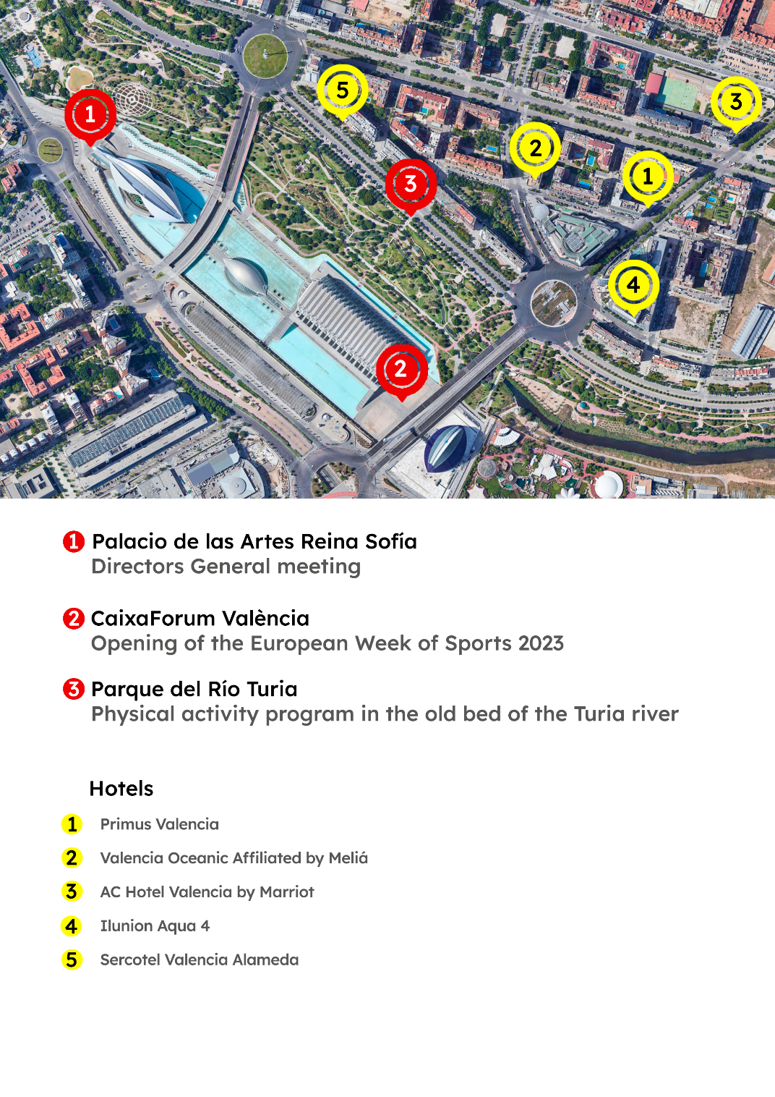

* The Physical Activity program will start exactly in this spot: https://maps.app.goo.gl/v2FehLLCF9tvHFyH9

Security
Providing a safe environment for delegations is of paramount importance to the Spanish Presidency. For security reasons, badges must be always worn visible. Access to the meeting venue will be denied in the absence of a visible worn badge.
Please note that all delegates will be asked to go via security check while entering the meeting venue.

Accommodation SPECIAL PRICES EXPIRED
The organization team kindly ask you to book your accommodation only via the links with preferential prices provided below as soon as possible. Capacities will be limited due to the concurrence of various international events.

- Hotel Primus Valencia 4* 14' walking
TELÉFONO +34 96 331 84 74
book through: comercial@hotelprimusvalencia.com

- Hotel Valencia Oceanic (Melia) 4* 12’ walking

- AC Hotel Valencia (Marriot) 17' walking

- Ilunion aqua 13' walking

- Sercotel Valencia Alameda 8' walking

Please note that the Presidency do not cover accommodation costs or additional expenses (beverages, minibar, lunches, etc.).

Meeting venue and facilities
The Spanish Presidency will provide all necessary services, such as a cloakroom, internet connection, and working facilities for delegations at the conference venues. The Wi-Fi password will be provided at the location. If you require photocopying, printing or scanning during the informal meeting, please inform the PRES team. There will be one central printing and photocopying point in the meeting venue.

Catering
Food and beverage will be provided throughout the events.

Interpretation
Simultaneous interpretation will be provided. The following languages will be available during the meetings: Spanish and English.
For the conference we will count also with sign language.

Contact
For any questions, please consult the coordination team at tel.:
Juan Martorell: +34662359196
Pilar Barrero: +34682693865
Belén Lara: +34608202624
Judith Masiá : +34647501186
or by email peue2023@csd.gob.es

General information
Emergency number: 112
Electricity: 230V, 50 Hz.
Local time: Central European Summer Time Zone (CEST) – GMT +1:00
Country code: Spain +34
Currency: euro
Tap water: Spanish water is regularly tested for quality and is safe to drink.

Presidency website
The website of the Spanish Presidency of the Council of the European Union 2023 contains information on all topics related to the Presidency available in Spanish, English.

Social media
All content related to the Spanish Presidency will be available on social media accounts:
Facebook: https://www.facebook.com/ConsejoSuperiordeDeportes/
Twitter: @deportegob or https://twitter.com/deportegob
Instagram: deportegob or https://www.instagram.com/deportegob
YouTube: https://www.youtube.com/CSD



